General Info
What: Our annual fall retreats focus on our student’s spiritual growth and formation. We will spend the weekend participating in worship, breakout sessions, small groups, and fun activities! The campus at Fort Caswell contains access to the beach and has old military forts that can be explored.
When: November 12th-14th
Cost: Early-registration special: $160 per person (if registered on or before Sunday, September 5th.
$180 per person (if registered AFTER Sunday, September 5th)
Trip Theme: Awaken Church- The speaker will be Sandy Marks, team leader of the Church Health & Revitalization Team with the Baptist State Convention of North Carolina.
Important: A $50 deposit AND a completed permission form are due ASAP. Your space will be reserved when we receive these items. The full balance is due before departure. We will continue to allow students to register until the lodging area reaches capacity.

About Fort Caswell
History: Tucked away on the eastern tip of Oak Island, Fort Caswell occupies the site of a former US military fortress. Since 1949, when the Baptist State Convention of North Carolina bought the property from the federal government, Caswell has been an instrument of peace, offering guests a place of quiet reflection and relaxation.
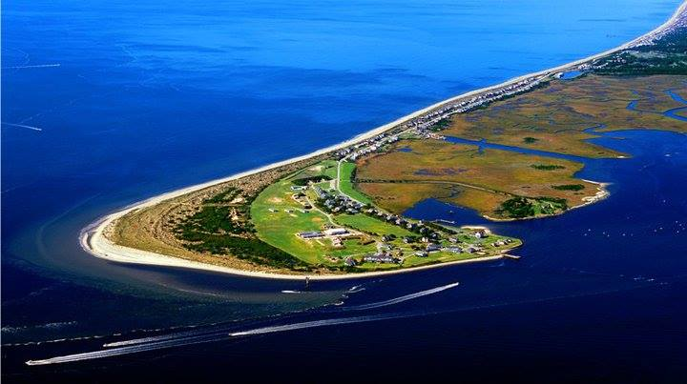
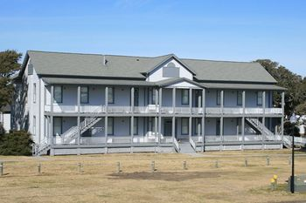
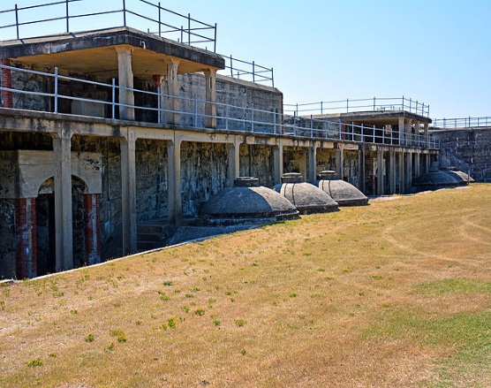
Campus: Fort Caswell campus comes equipped with housing barracks, cafeteria, worship building, small group rooms, volleyball net, indoor basketball court, beach access, gift shop, and more! Numerous concrete forts can also be explored.

Have Questions? Please contact Travis Suttles at 336-953-9069 or travis@brookwood.cc for more information.
Purpose
Frontline Student Ministry generally offers at least two annual trips. The first is a week-long summer mission trip focused on service and gospel advancement. As a group built around the call to “go and make disciples” these mission projects are a clear priority.
We also offer a weekend fall retreat toward the end of each year. While there is no service component to these weekends, we believe they hold a specific value for our students. These retreats focus primarily on worship, discipleship, and personal spiritual growth. The goal is to break away from the normal stress and distractions of school, work, sports, etc, and focus solely on our Savior.
Scholarship Opportunities
- Please plan to take advantage of our early registration special! Students who turn in their permission form and $50 deposit on or before Sunday, September 5th will receive the best possible rate ($160 per person).
- We also offer a discount for multiple participants from the same household. The first participant will pay the normal fee. Each additional participant from the same household will receive $20 off the cost of their trip.
- If a student is serious about attending this trip, but funding is an issue, please contact Travis Suttles. Additional scholarships may be available. We believe these trips are an important part of student’s spiritual formation and will help ensure their participation any way we can.
Rules/Safety Info
- Fort Caswell/s campus is a gated community located at the end of a peninsula. Only authorized individuals and registered church groups will be permitted access.
- Students will be strictly required to remain in groups of three or more at ALL times. No student should be alone by themselves or alone with another student.
- Lodging will take place in one of two forms. 1) Our team will have access to a multi-story house-style lodging area designed for groups. In this case, female students and leaders will be given exclusive access to the second floor. Male students and leaders will occupy the first floor. At NO point during the week will male students be permitted to enter the second-floor area. 2) Our group will occupy large, barrack-style, lodging with other church groups. Male and female barracks are located in separate buildings, and each features numerous bunk beds and bathroom/shower facilities. We will be assigned one of these areas after registration.
Guide for Appropriate Dress
The following dress code will apply to all Frontline Student Ministry activities (including Sunday mornings and Wednesday nights) and trips. It applies to all students and leaders. Our goal is to maintain a respectful atmosphere that is honoring to Christ. To ensure that we maintain a Christ-like culture and an open opportunity to share the gospel, the following guidelines will be required.
Participants will be asked to change if they do not meet the following guidelines.
- Clothing may not contain language, pictures, advertisements, or symbols of an offensive nature.
- Sleeveless shirts should be modest in every way. Shirts that are low-cut, tight-fitting, or cropped in a way that is revealing are not permitted.
  - As a general rule, sleeveless shirts are not permitted on week-long mission trips.
- Shorts should be modest in length, no shorter than mid-thigh level.
- Clothing with tears or holes in inappropriate places is not permitted.
- Clothing should not be tight-fitting or exposing in any way.
- Should a trip involve an opportunity to swim, all swimwear must be modest and fit the following requirements:
- Males: short-style worn on the hips, not below.
- Females: one-piece suits, or two-piece suits on which the two pieces meet.
Caswell Fall Retreat Packing List
Lodging Needs:
Each participant can expect a bunk-bed-style lodging arrangement (twin-size). These beds will have a mattress, but additional bedding will not be supplied.
Please remember not to overpack, as you may only have a small area around your bed to store your bags.
Each lodging area will be equipped with several bathroom stalls and showers.
- Pillow
- Blanket and fitted sheets or a sleeping bag
- Towel(s)
- Washcloth
- Soap
- Deodorant
- Toothbrush
- Toothpaste
- Shampoo
- Hygiene items as needed
- Shower shoes
- Please check the weather in Oak Island, NC, and make sure you pack accordingly!
Other items:
- Bible
- Notebook
- Pen
- Water bottle
- Good attitude
- Drawstring or small bag
- Money for TWO fast food meals
- Money for snacks, drinks, or souvenirs (if desired)
- Watch or device other than your phone that can tell time (if desired)
- Flashlight (if desired)
Do NOT Bring:
- Alcohol, tobacco, illegal drugs
- Weapons of any kind (guns, pocket knives, etc.)
- Any clothing that does not meet Frontline’s dress code.
Phone Policy
We highly recommend limiting the number of electronics. Students may bring their phones and game systems and use them freely during the commute. However, once we arrive on campus, all phones/other electronics will be collected by our leaders for the weekend.
We do this to ensure that our phones and other electronics do not become a distraction that causes us to miss how God is moving on our trips and retreats. Students will be permitted temporary access to their phones to contact their families.
Meals
- We plan to stop for a fast-food meal on to way to AND from Caswell. Students will need to bring money for these two meals.
- Once we arrive at the Caswell campus our meals for the weekend will be provided by their cafeteria.
- There will be a store on campus that will sell snacks, drinks, and souvenirs.
Caswell Fall Retreat 2021
Schedule (Projected)
Friday (Nov 12th)
3:00 pm Meet at Brookwood
5:00 pm Dinner (off campus)
6:30pm Arrive at Caswell Campus
8:00 pm Welcome and Worship Hatch Auditorium
9:30 pm Adult Leader Meeting* Hatch Auditorium
10:00 pm Church Group Devotions Assigned Classrooms
11:00 pm In Rooms
11:45 pm Lights Out

Saturday (Nov 13th)
7:30 am Breakfast Cafeteria
8:45 am Quiet Times
9:00 am Good Morning Frenzy Hatch Auditorium
9:30 am Small Group Study #1 Assigned Classrooms
10:45 am Worship Hatch Auditorium
12:00 pm Lunch Cafeteria
1:30 pm Track Times
2:30 pm Free Time
5:30 pm Dinner Cafeteria
6:30 pm Welcome Back Hatch Auditorium
6:50 pm Small Group Study #2 Assigned Classrooms
8:00 pm Snacks Hatch Auditorium Porch
8:15 pm Worship Hatch Auditorium
10:00 pm Church Group Devotions Assigned Classrooms
10:30 pm Free Time
11:30 pm In Rooms
11:45 pm Lights Out

Sunday (Nov 14th)
7:30 am Breakfast Cafeteria
8:45 am Quiet Times
9:00 am Welcome Hatch Auditorium
9:15 am Small Group #3 Assigned Classrooms
10:00 am Worship Hatch Auditorium
11:30am Lunch (off campus)
12:30pm Depart for Wilmington Battleship
1:00pm Arrive at Wilmington Battleship
3:00pm Depart Wilmington Battleship toward BBC
4:30pm * Arrive for pickup at BBC

*Note: We will have students call or text their parents when we are an hour away from Jacksonville to confirm our pickup time.

Frontline Students Mission Trip Medical and Permission Form

Student Info:
Student’s Name: _______________________________ Age: ___________ Date of Birth: ___/___/___
Mailing Address: _________________________________________________ Phone #: _________________
In case of emergency notify: ____________________ Relation: ________ Phone #: _________________
Trip Location: _________________________________

Parent/Guardian Info:
Parent’s Name(s): ________________________________ Parent’s Phone #: ____________________
Parent’s Address: ________________________________ Parent’s Email: ______________________

Medical Info:
Do you have any food allergies? (Circle One) Yes No
Do you have any allergies to medications? (Circle One) Yes No
Do you have any special dietary requirements? (Circle One) Yes No
Are you currently taking any medications? (Circle One) Yes No
Do you have any medical difficulties that we should be aware of? (Circle One) Yes No
Do you typically experience motion sickness in vehicles? (Circle One) Yes No
If yes to any, please explain:
_________________________________________________________________________________________________________________________________________________________________________________________________________________________________________________________________________________________________________________________________________________________________________________________________________________________________________________________________________________________________________________________________________________________________________________________________________________________________
Date of last Tetanus Immunization ___/___/___ Family Physician: _______________________

Insurance Info:
Insurance Company Name: ____________________________ ID#: ___________________________________
Group #: ________________ Subscriber Contact Number: _______________________________
Subscriber Name: _____________________________________ Subscriber Date of Birth: ____/____/____
Subscriber Place of Employment: ________________________ Subscriber Occupation: _______________
Permission Form and Photo Notice:
My child (named above) has permission to participate in this Frontline Students event. I authorize the adult leaders representing Brookwood Baptist Church, and/or any medically trained professional to obtain necessary medical attention for my child in case of sickness or injury while participating in this activity; and I give my permission for Brookwood youth leaders to disclose any important medical information about my child with the medically trained professionals.
I hereby take full responsibility for the actions of my child while participating in this activity.
I also give my permission for photographs of my child to be posted on Frontline’s private Facebook and Instagram pages.
Student’s Signature: ________________________________________ Date: ___/___/___
Parent/Legal Guardian Signature: ________________________________________ Date: ___/___/___
Parent/ Legal Guardian name (print): ________________________________________ Date: ___/___/___

Acknowledgment of Expectations:
By signing below, I acknowledge my responsibility to give my best effort in the following areas:
- Love the Lord with all your heart, soul, and Mind: Matthew 22:37 “Love the Lord your God with all your heart and with all your soul and with all your mind.”
- Love your Neighbor: Mark 12:31 “Love your neighbor as yourself”
- Set the Standard: We expect you to show others what it looks like to honor Christ through word, thought, and action.
- Be Attentive and Participate: This trip requires your full engagement and participation. We expect all our team members to be on the frontlines of our work.
- Always stay in groups of Three or More: This is critically important for safety and accountability. Students should NEVER be in groups of fewer than three people.
- Don’t let your Phones be a Distraction: The nature of serving in a large city means that communication will be key. However, we expect that each participant will refrain from allowing their phones to be a distraction. This includes time on our mission site, as well as time spent together during our free periods.
- Follow the Dress Code: Our goal is to honor and reflect Christ in every aspect of our lives.
- Be Responsible: This trip is only open to students willing to be responsible. Our leadership team will do our very best to lead well. However, it is your responsibility to pay attention while navigating the city, make wise and safe decisions, keep up with your belongings, manage your money, etc.
- Be Flexible: The details of this trip have been carefully planned. However, the nature of mission trips often requires flexibility. Our goal is to serve Covenant Community Church to the best of our ability.
- Be Prepared to Share the Gospel: Our trip will involve many opportunities for face-to-face conversations. Our church planting team will do their best to set us up with gospel opportunities. We expect our team to be prepared to share the hope of the gospel through tools such as the Three Circles, 15 Second Testimony, or their personal story.
- Follow Social Distancing Guidelines: We will be serving in a major city in a different state. Be prepared for mask use and social guidelines to potentially be stricter than in our Jacksonville area. We will adhere to any guidelines from the team at Covenant Community Church.

I have read the expectations above and agree to do my best to meet these goals.
Student’s Printed Name: ________________________________________
Student’s Signature: ________________________________________ Date: ___/___/___

