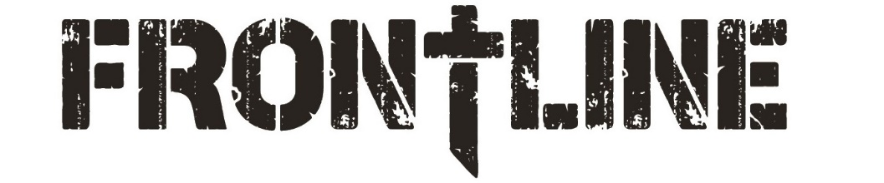
Brookwood Students Dress Code
The following dress code will apply to all Brookwood Students’ meetings (including Sunday mornings and Wednesday nights) and trips. In the event that we partner with other organizations for events or mission projects, their dress code will also apply. Our goal is to create an atmosphere that is respectful and ensures people’s focus is on Christ rather than on us. To ensure that we maintain a Christ-like culture and an open opportunity to share the gospel, the following guidelines will be required.
Clothing:
- Do not wear T-shirts or other clothing with offensive language, advertisements or pictures.
- Short shorts will not be permitted any time. Shorts worn on any Brookwood Student event should be BELOW mid-thigh These guidelines also apply to skirts and dresses. (See chart below)
- Sleeveless shirts are permitted, as long as they are modest. Spaghetti straps and low fitting tops will not be allowed. T-shirts with large, open, holes around the sleeves (commonly worn as workout shirts) also should not be worn.
- Long pants that have open rips and/or holes above mid-thigh will not be allowed.
- No tight-fitting apparel (i.e. tight dresses, mini-skirts, compression pants, etc.) is permitted at any time.
- All shirts should be full length. No clothing that exposes your midriff area will be permitted.
- Shirts or dresses with an open back or a low neckline should not be worn.
Swim Wear:
- If there is an opportunity to swim during any Brookwood trip, bikinis and low-riding shorts will not be allowed.
- Female swim wear should be one-piece suits or modest two-piece suits (Modest is a tankini type swimsuit where the top and bottom pieces are touching).
- Male suits should be board-typed shorts that are worn above the hips. Low riding suits or suits above mid-thigh are not permitted.
